5.2: In all cases, each string is supporting a weight w against gravity, and the tension in each string is w. Two forces act on each mass: w down and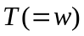 up.

